Day 2 Homework: Variables and Conditional Statements

1. Given the following code, print a , b , and c on three separate lines

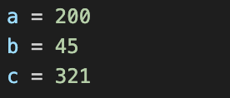

|  |
| --- |
| # your code here  Print(a)  Print(b)  Print(c) |

1. Given the following code, print a , b , and c on the same line.

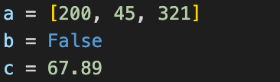

|  |
| --- |
| # your code here  Print(a,b,c) |

1. Write code that prints “Selam” if the number entered by a user is a multiple of 3. If the number is not a multiple of 3, print “Goodbye”.

|  |
| --- |
| # your code here  User_number = input(welcome)  Is_multiple = int(user_number)%3  If is_multiple == 0:  Print(“Selam”)  Else:  Print(“Goodbye”) |

1. Write code so that when the user enters a number *n*, the program prints a grade letter corresponding to the following grade cutoffs:

**A** → *n* >= 90  **B** → 80 <= *n* < 90 **C** → 75 <= *n* < 80  **D** → 70 <= *n* < 75  **F** → *n* < 70

|  |
| --- |
| # your code here  point = 80  if point >= 90:  print(“A”)  elif 80 <= point <90:  print(“B”)  elif 75 <= point <80:  print(“C”)  elif 70 <= point <75  print(“D”) elif point < 70:  print(“F”) |

1. Write code that takes in 3 numbers from the user and tells the user whether or not forming a triangle is possible with side lengths corresponding to those 3 numbers.

***Hint:*** There is a theorem, “the sum of two sides of a triangle must be greater than the third side. If this is true for all three combinations, then you will have a valid triangle.”

|  |
| --- |
| # your code here |

1. Write code that accepts 3 numbers from the user and determines which of the 3 is the largest number and the smallest number. Think about any unusual cases as well!

|  |
| --- |
| # your code here  print(“Enter number”)  number1 = input()  number2 = input()  number3 = input()  total_num = number1, number2, number3  highest_num = max(total_num)  lowest_num = min(total_num)  print(highest_num)  print(lowest_num) |